Simplifying Db2 Server setup : Quick Install for Linux/AIX

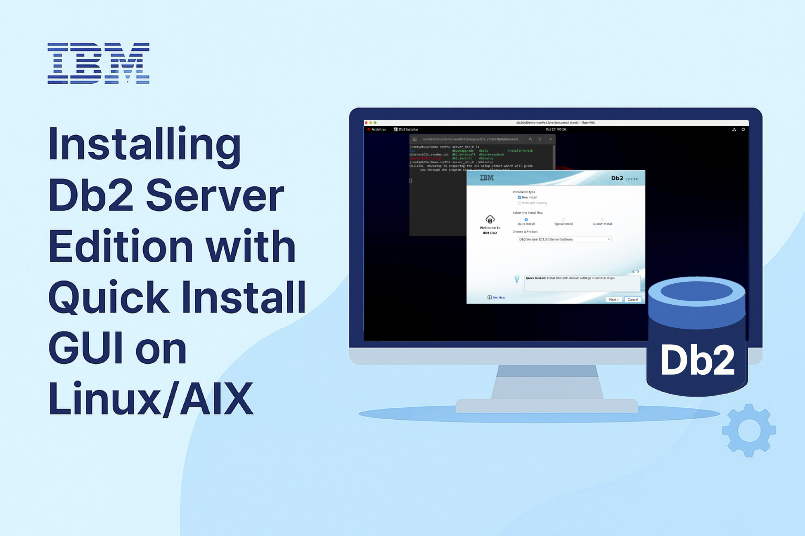

## Say Hello to Quick Install – A Simpler Start to Your Db2 Journey

Think Db2 setup is complex? Think again – Starting with Db2 version 12.1.3, introducing a brand-new Quick Install flow with a modernized GUI installer that lets you install IBM Db2 Server Edition on Linux/AIX in minutes! If you’re looking for a fast, hassle-free way to install Db2, Quick Install is the way to go. With just a few clicks, you can have Db2 up and running. Whether you're a seasoned sysadmin or a developer exploring database deployment, this blog walks you through the quick installation process as root user and shows how easy it is to get started.

## Step-by-step Installation Walkthrough

### Kick-off the GUI Installer

Start by launching the *db2setup* utility from the extracted Db2 installation image via your desktop environment.

**Tip:** Looking for the Db2 installation image? Confused about the environment setup or pre-requisites? Head over to the Wrapping-Up section at the end of this blog for the details.

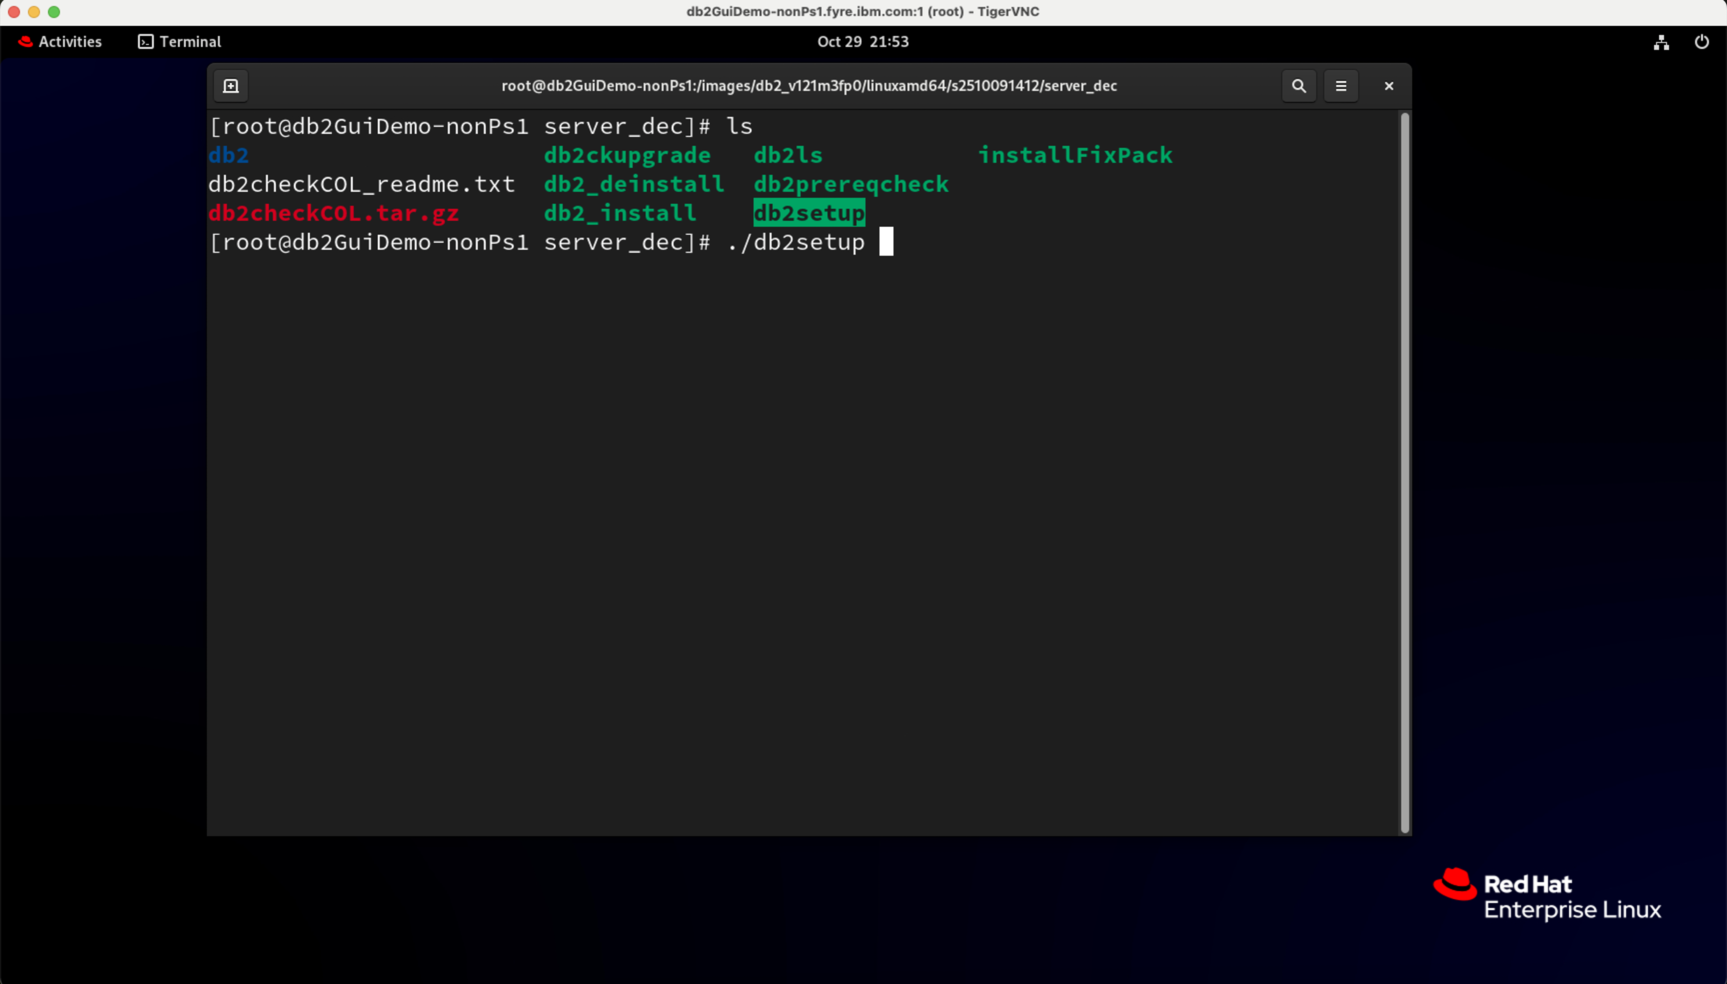

### Say Yes to the License terms

Before diving in, take a moment to review the IBM and non-IBM license agreements. Once you’re ready, click the *I agree* radio button to move to the next step.

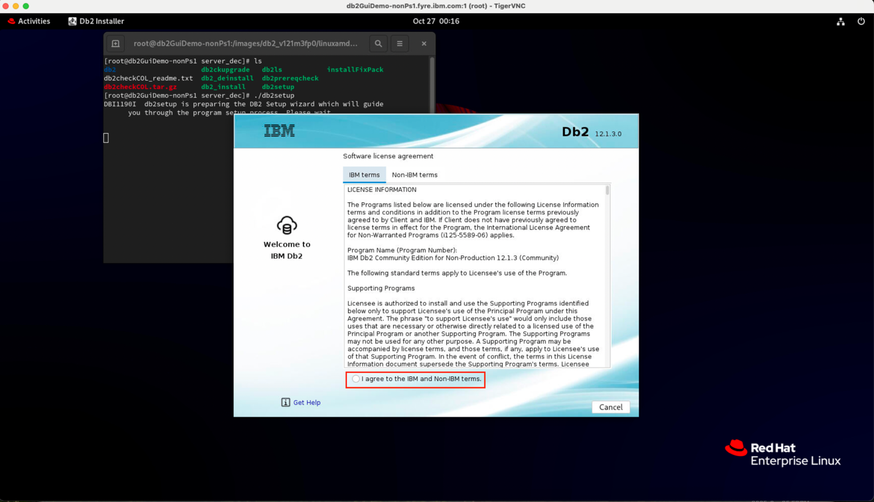

### The Fast Lane to Db2 starts here

On the Installation type screen, the stage is set: *Quick Install* and *Db2 Server Edition* are preselected and ready for action. Hit *Next*.

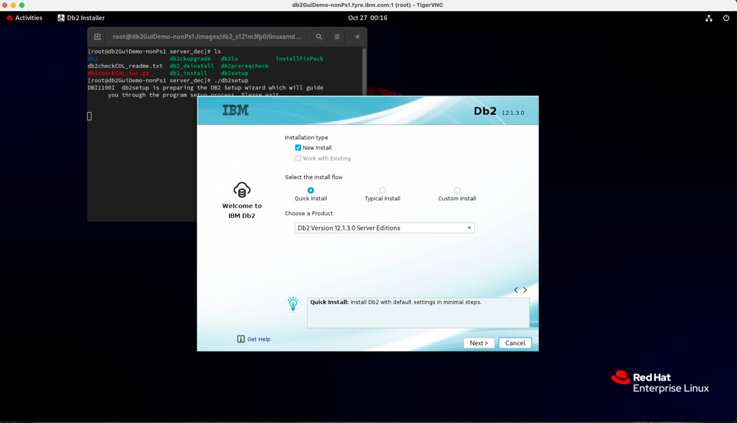

### Ready to Install

On the Summary screen, review the details and click *Install* to begin the installation.

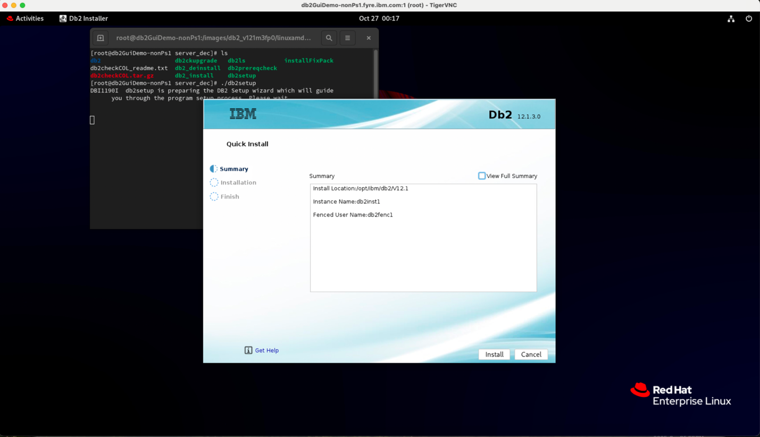

### Installing…. Almost there!

Sit back and watch the progress as Db2 installs.

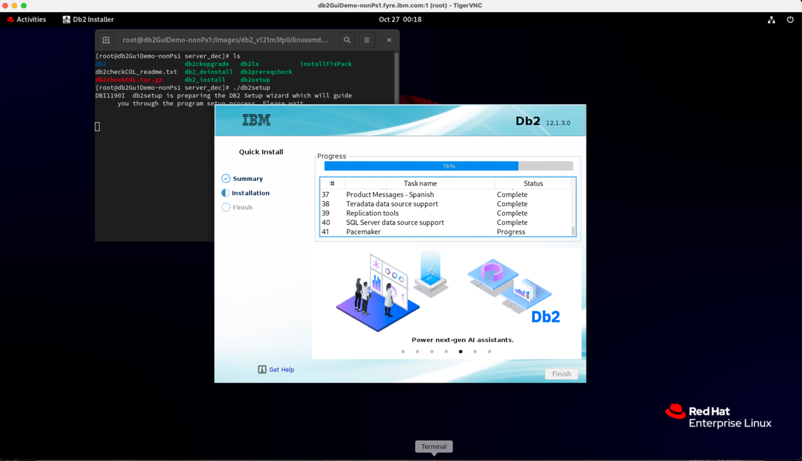

### Db2 Installed – View your password

Installation complete! Click the Eye icon to reveal the installer-generated password for the instance and fenced user.

**Note:** The password is shown only once and is not stored anywhere. If you skip this step, the administrator (root) will need to reset them later.

### Hit Finish and Start your Db2 journey

Securely stored your password? Great! Click Finish to wrap up the setup and begin using Db2.

## Wrapping-Up – Few Handy Links & Tips

### **Get started with Db2 Community Edition**

New to Db2 and not sure where to begin? The [Db2 Community Edition](https://www.ibm.com/products/db2/get-started#Download+Db2+Community+Edition) is a great starting point for your Db2 journey—free, feature-rich, and beginner-friendly.

### **Setup the database server environment**

Checkout the official IBM documentation on [Preparing to install Db2 database servers](https://www.ibm.com/docs/en/db2/12.1.x?topic=servers-preparing-install-db2-database) to ensure your environment is properly setup.

### Optimize your GUI installer experience

For the best visual experience, use a high desktop resolution when working with the Db2 GUI installer. All screenshots in this blog were captured via [TigerVNC](https://tigervnc.org/) on a Mac, connected to a RHEL 9.6 server running GNOME desktop. VNC server resolution of 2000×1200 delivered excellent clarity on this setup. Lower resolution like 800×600 can distort interface elements and give you a less polished experience.

### Non-root Quick installation

This walkthrough focused on root installation. But if you’re working without root access, the Quick Install option is supported for non-root users also. The install process is similar, with the key difference being that there is no password reveal option, as the password would be the same as your non-root user.

## About the Authors

Ajomon Mathew is a Software Development Manager at IBM, leading the Db2 Deployment, Connectivity, and Extenders team within the Data and AI division. With deep expertise in enterprise software engineering, Ajomon has driven key innovations in Db2 installation, automation, and text search modernization. He is passionate about simplifying complex systems, mentoring future leaders, and exploring the intersection of AI and data platforms. Ajomon is based in Kochi, Kerala, and actively contributes to IBM’s internal knowledge-sharing and product strategy initiatives.

Balanarayan K is a Senior Software Developer in the Db2 Deployment team at IBM, based in Kochi, Kerala. He focuses on streamlining Db2 installation workflows and enhancing deployment experiences across platforms. A seasoned technologist, he brings experience from diverse domains like IoT, Embedded Systems and Automotive. With a strong foundation in engineering and a passion for knowledge sharing, he brings a unique blend of technical depth and practical insights to every project he undertakes. He is also known for his contributions to internal and collaborative technical enablement.

Naveen Balachandran is a Software Developer currently working with the Db2 Connectivity team at IBM. He has previously made impactful contributions in modernizing the Db2 GUI installer, particularly through enhancements to the Java framework. He is passionate about exploring new programming languages and technologies and brings a consistently positive and proactive approach to every task he involves with. His enthusiasm for learning and innovation makes him a valuable contributor to the Db2 ecosystem.